**Division**

1. Work out 765 ÷ 3
2. Work out 2725 ÷ 4
3. Work out 8273 ÷ 6
4. 324 pineapples are cut into 72 chunks, then put into tin cans which hold 24 chunks each. How many tin cans will be needed?
5. Write down the missing number in each part:
6. 1400 x _______ = 70000
7. 1400 x _______ = 700
8. 1400 ÷ _______ = 7
9. A crate holds eight milk bottles. How many crates can be filled using 364 bottles, and how many bottles will be left over?
10. Steve’s van can carry 52 boxes. Steve has 2240 boxes to move from Hampstead to Northwood. How many round trips must the van make to transport all the boxes?

**Division**



1. Work out 765 ÷ 3

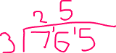

1. Work out 2725 ÷ 4

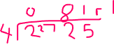

1. Work out 8273 ÷ 6



1. 324 pineapples are cut into 72 chunks, then put into tin cans which hold 24 chunks each. How many tin cans will be needed?

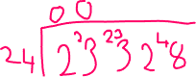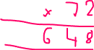

1. Write down the missing number in each part:



1. 1400 x _______ = 70000



1. 1400 x _______ = 700



1. 1400 ÷ _______ = 7



1. A crate holds eight milk bottles. How many crates can be filled using 364 bottles, and how many bottles will be left over?



1. Steve’s van can carry 52 boxes. Steve has 2240 boxes to move from Hampstead to Northwood. How many round trips must the van make to transport all the boxes?

