Complete the series
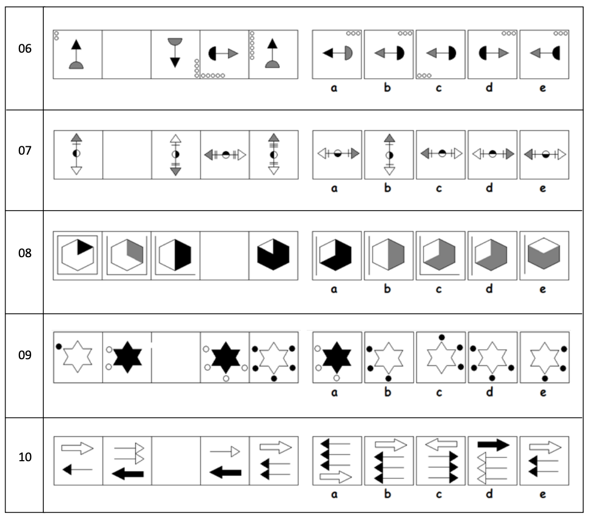

§

Figure like the first two
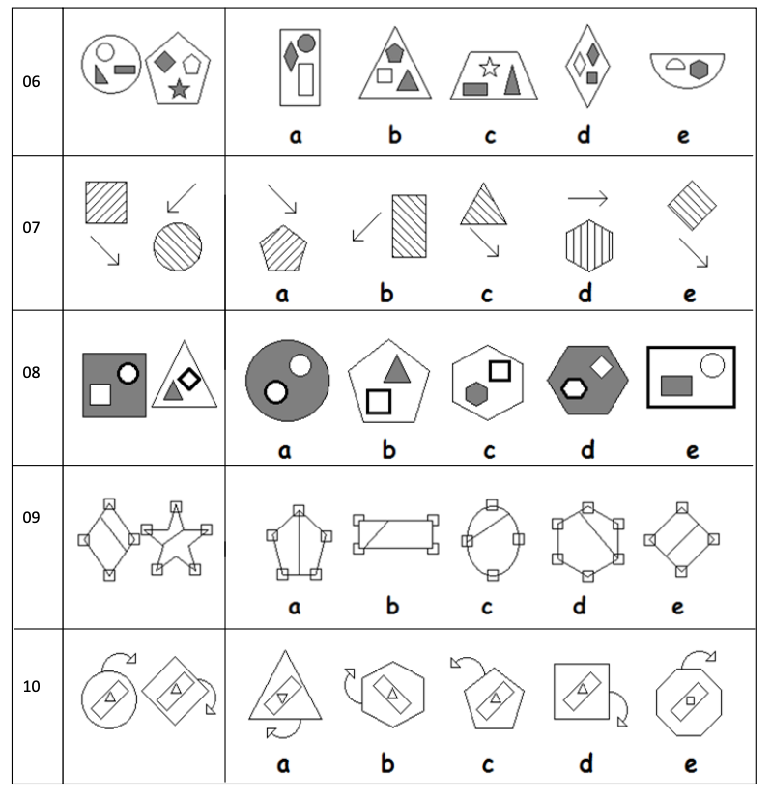

Complete the pair
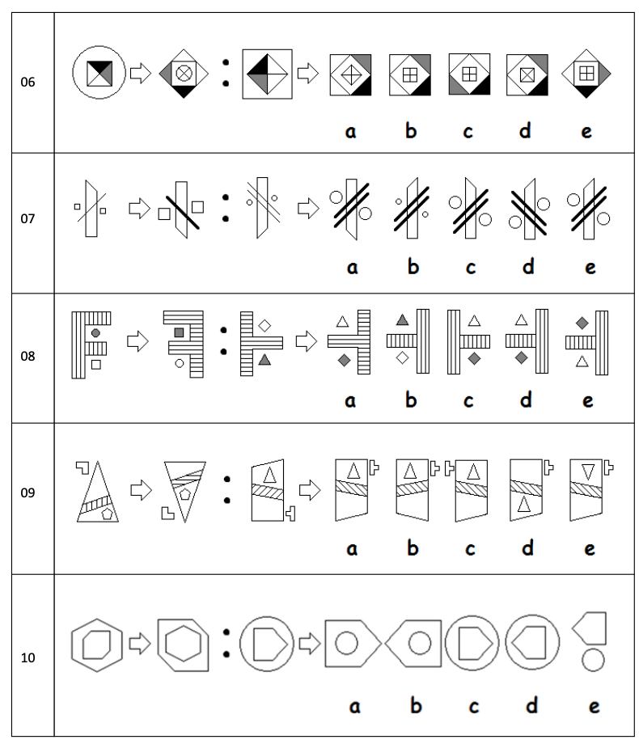

Odd One Out
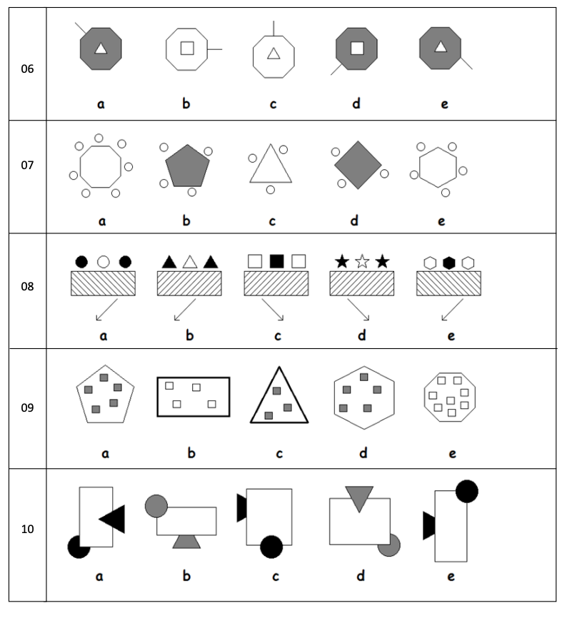

Maths

- 42 x 16 = 672

- 73 x 24 = 1752

- 26 x 51 =1326

- 6432 ÷ 100 = 64.32

- 0.37 x 100 = 37

- 80312 ÷ 1000 = 80.312

- 1.2 x 7 = 8.4

- 0.4 x 3 =1.2

- 5 x 1.1 = 5.5

- Write down the first 12 square numbers.

1, 4, 9, 16, 25, 36, 49, 64, 81, 100, 121, 144

Spelling
