**



**Alphabet Codes**

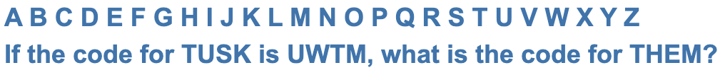







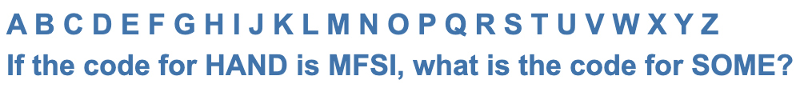



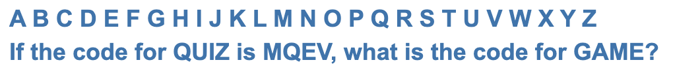



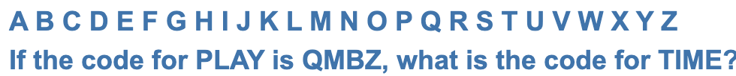



**Fractions**

