**Fractions**

1. Calculate 2/5 + 3/10
2. Which fraction is greater 4/7 or 6/11?
3. 5/8 of 136?
4. What fraction of the shape has been shaded?

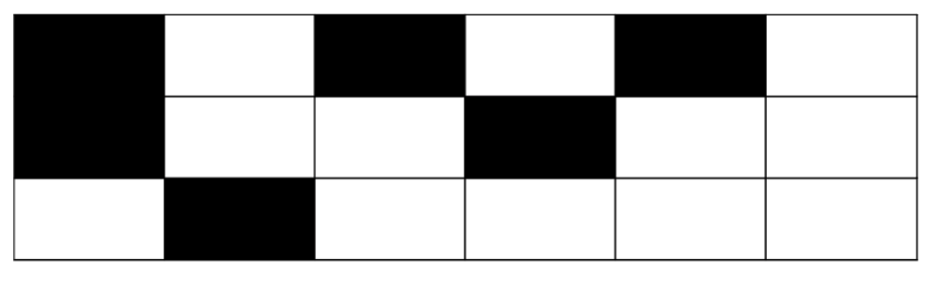

1. Three quarters of a local tennis club are girls. There are 20 boys in the club. How many are girls?
2. Two fifths of £330
3. Write down the next fraction in this sentence:

5/8, 10/16, 15/24, ____

1. Circle the largest fraction.

½ 5/12 2/3 5/6 1/3

1. In a kettle there are 1 ¼ litres of water. A cup holds 2/7 of a litre of water. How many cups of water can be filled from the kettle?
2. How many fifths are there in 11?

11 15 22 34 55

1. Lisa is painting her fence. Her fence has 18 posts. Lisa paints 1/3 of them red. How many posts were not painted red?