Alphabet Codes

(Remember to draw on the pattern for each letter, as it may change)
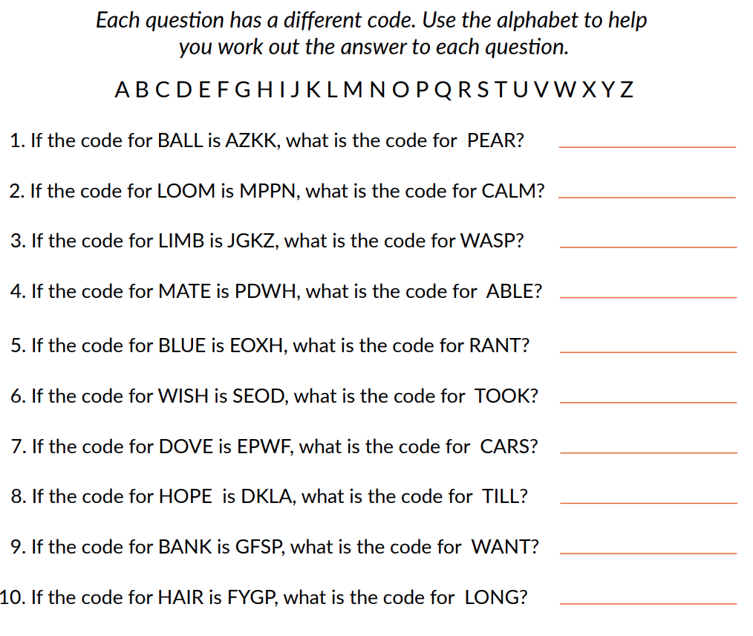

Answers

