Converting fractions, percentages, and decimals -Part 2

Remember to make your decimals to 2 decimal places = 0.2 = 0.20
Remember to make your fractions out of 100 first.
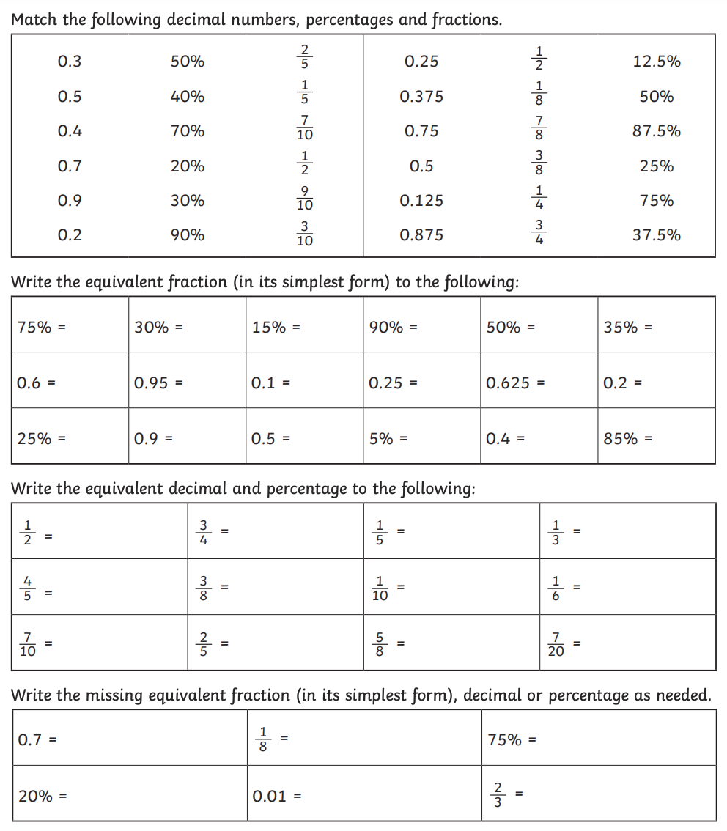

Answers
