Word ladders
Change one letter at a time (they must be the letters in the last word)
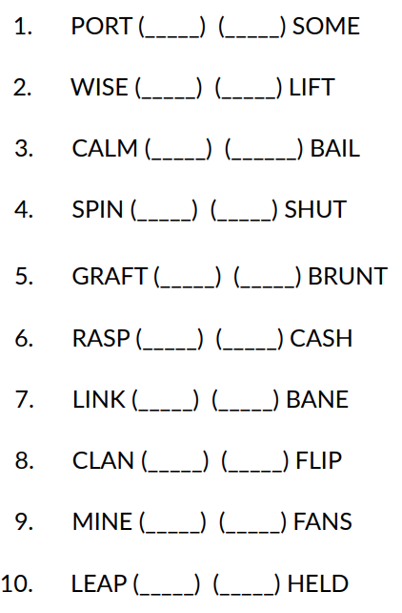

ANSWERS

- SORT SORE
- WIFE LIFE
- CALL BALL
- SPUN SHUN
- GRANT GRUNT
- RASH CASH
- LINE LANE
- CLAP FLAP
- FINE FINS
- LEAD HEAD

