Verbal Reasoning – Number sequences

Remember to look at each jump, if there isn’t a pattern. Check double sequences and adding the number before.

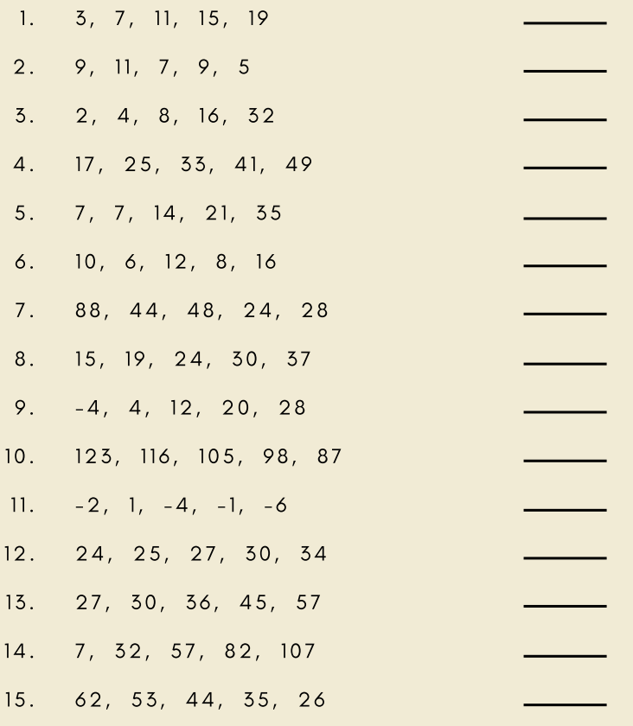

Answers

