**Non-Verbal Reasoning - Figure like the first three**



**Complete the series**



Maths – Fractions, Decimals and Percentages

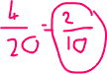

**English – Circle the synonyms – Then write an antonym for each**

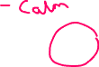



**Verbal Reasoning – Anagrams – Find the missing letter of the scrambled words**

